SOLUTION OF MODULE 4
Question1: https://www.hackerearth.com/problem/algorithm/digit-sum-4/
#include <stdio.h>

int main() {
int t;
scanf("%d", &t);

while (t--) {
long long n;
scanf("%lld", &n);

int last_digit = n % 10;
int first_digit = n;

while (first_digit >= 10) {
first_digit /= 10;
}

long long sum = first_digit + last_digit;
printf("%lld\n", sum);
}

return 0;
}
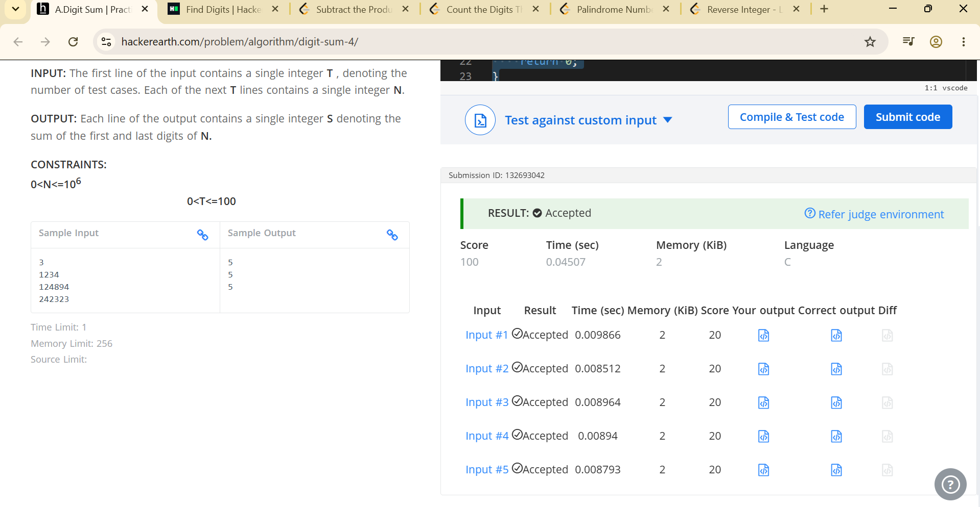
Question 2: https://www.hackerrank.com/challenges/find-digits/problem


Question 3: https://leetcode.com/problems/subtract-the-product-and-sum-of-digits-of-an-integer/description/
int subtractProductAndSum(int n) {
int product = 1;
int sum = 0;

while (n > 0) {
int digit = n % 10;
product *= digit;
sum += digit;
n /= 10;
}

return product - sum;
}

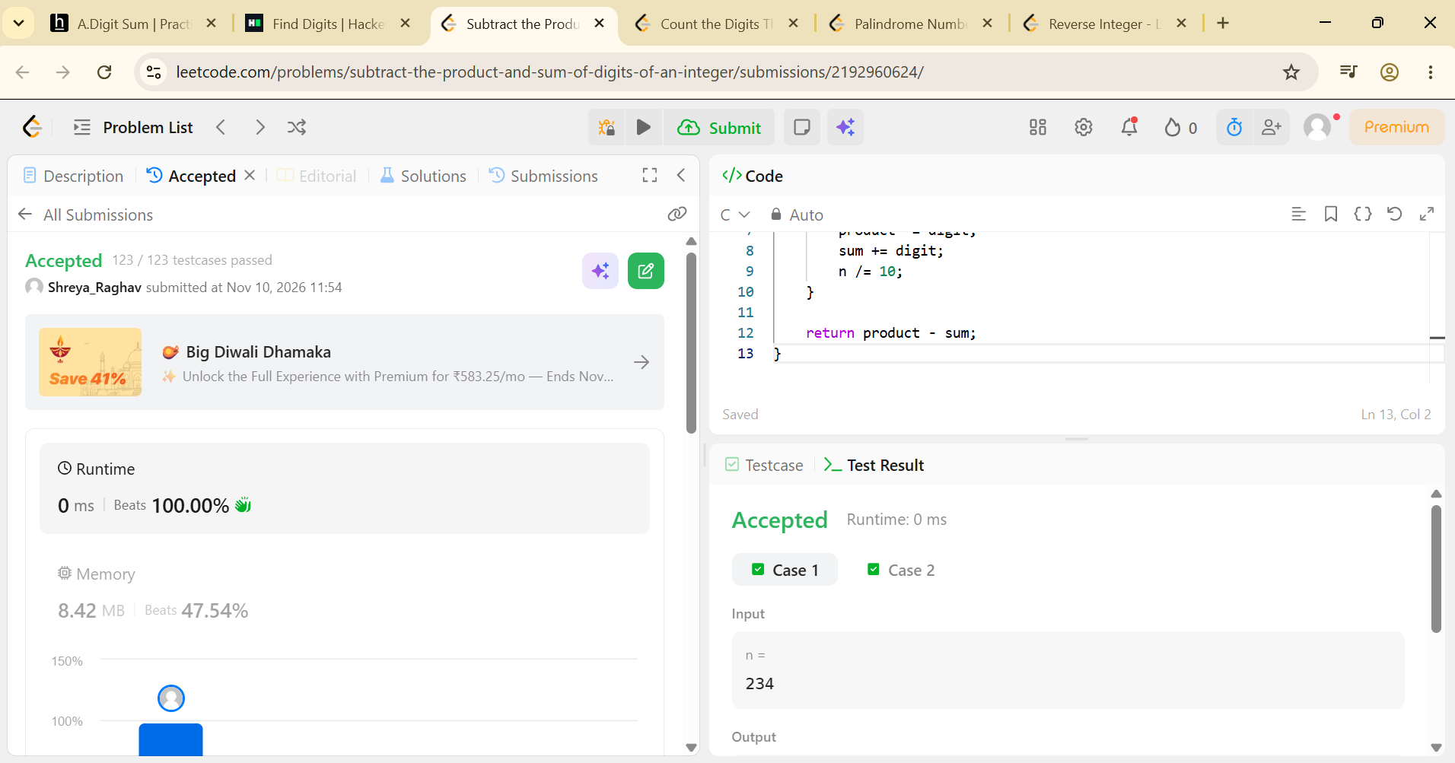

Question 4: https://leetcode.com/problems/count-the-digits-that-divide-a-number/description/
int countDigits(int num) {
int count = 0;
int original = num;

while (num > 0) {
int digit = num % 10;
// Check if digit divides the original number evenly
if (original % digit == 0) {
count++;
}
num /= 10;
}

return count;
}
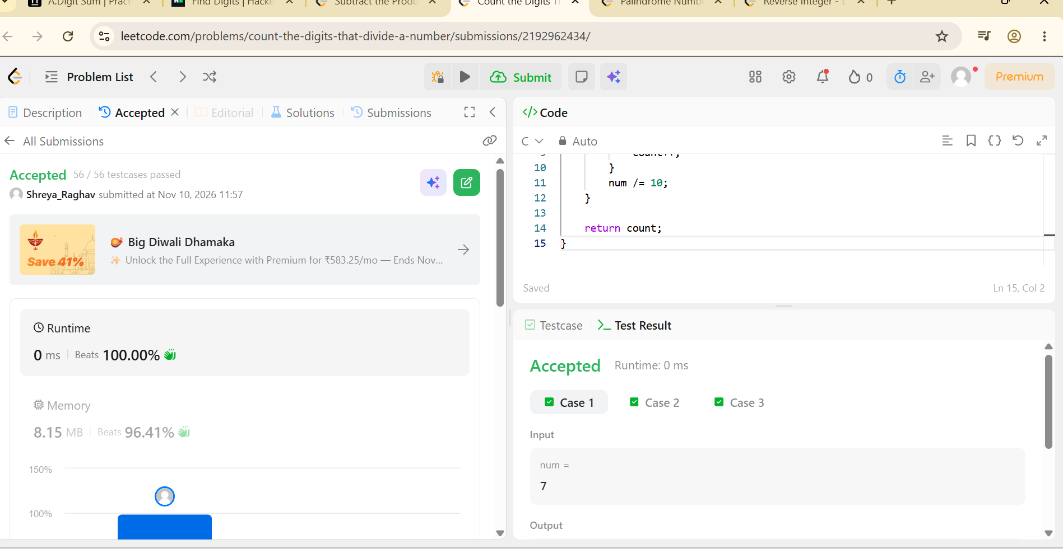

Question 5: https://leetcode.com/problems/palindrome-number/description/
bool isPalindrome(int x) {
// Negative numbers and numbers ending in 0 (except 0 itself) cannot be palindromes
if (x < 0 || (x % 10 == 0 && x != 0)) {
return false;
}

int reversed_half = 0;
while (x > reversed_half) {
reversed_half = reversed_half * 10 + x % 10;
x /= 10;
}

// When the length is an odd number, we can get rid of the middle digit by reversed_half / 10
return x == reversed_half || x == reversed_half / 10;
}

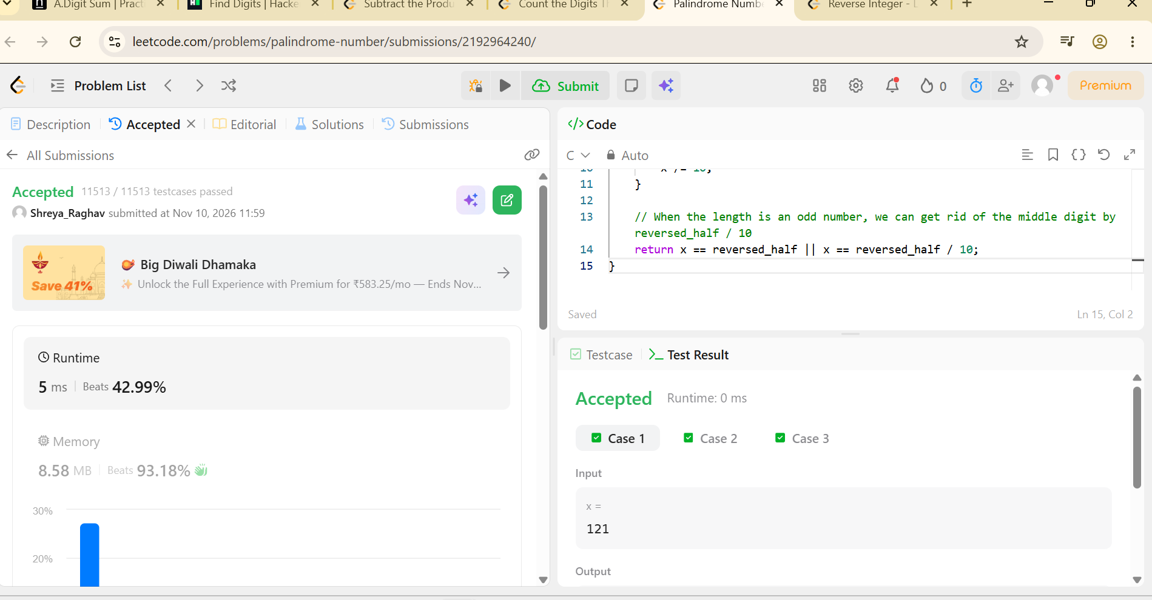

Question 6: https://leetcode.com/problems/reverse-integer/description/
int reverse(int x) {
long long rev = 0;

while (x != 0) {
int pop = x % 10;
rev = rev * 10 + pop;
x /= 10;
}

// Check for 32-bit signed integer overflow/underflow
if (rev > INT_MAX || rev < INT_MIN) {
return 0;
}

return (int)rev;
}

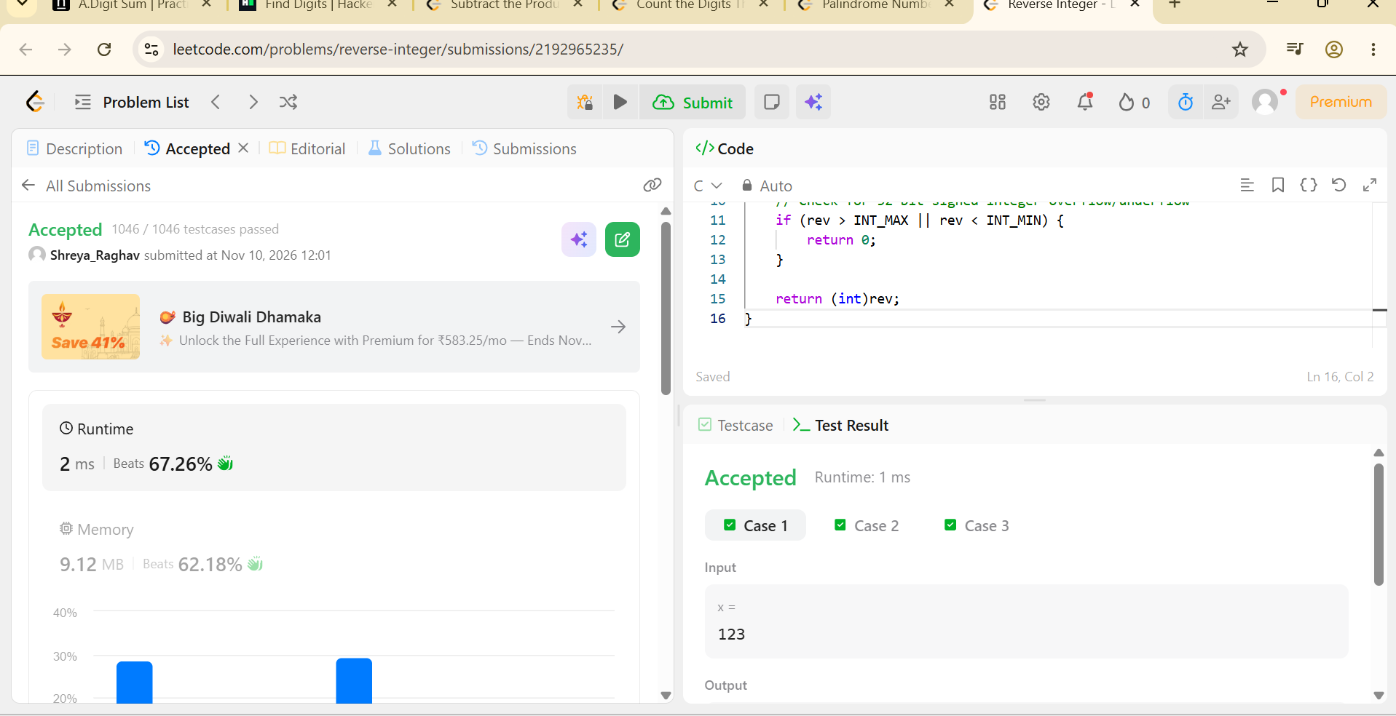s

